- Make sure you are in the MTSOA tab in arbiter to write the report then click on the schedule tab
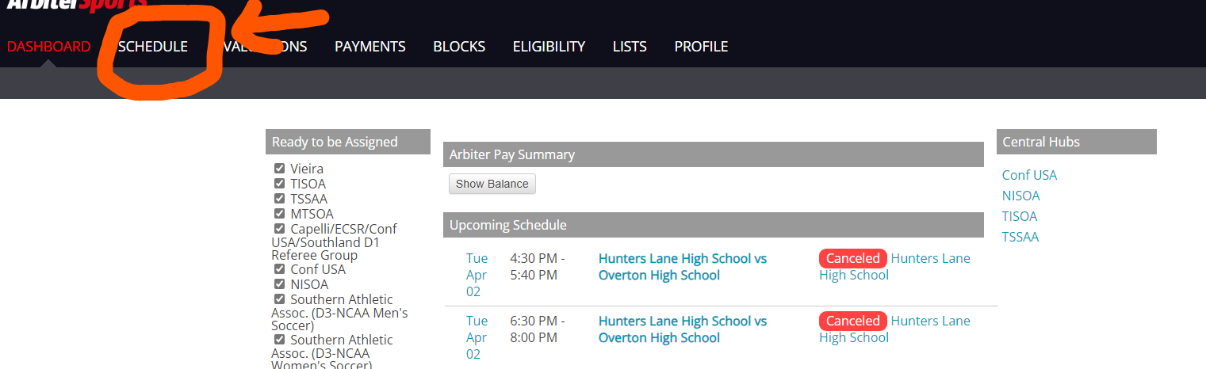
- Once on your schedule, click the icon that looks like the corner of the piece of paper has been folded
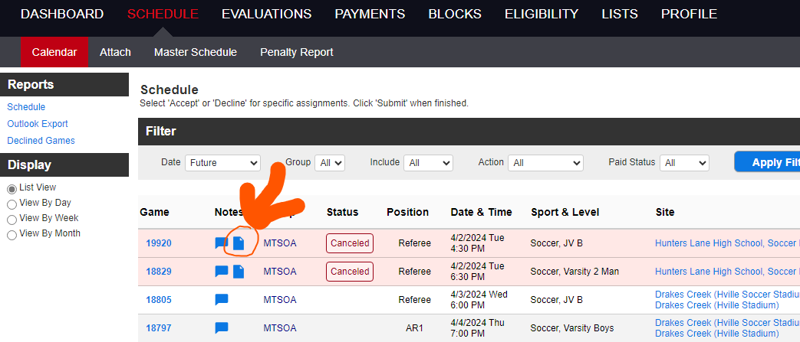

- Make sure you enter the score and the write the report and be as detailed as possible, have the book in front of you and use the proper language. If you have an ejection or any other need, then click the box next to unusual situation form and click on those words that take you to the TSSAA website. Make sure you copy your report from the comments section in arbiter, to transfer it to the TSSAA report
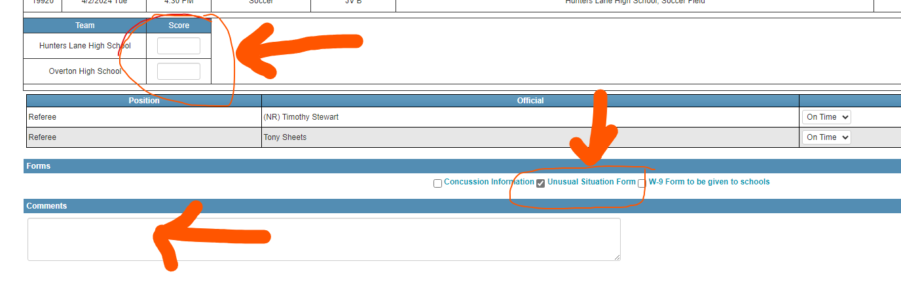
Examples of Reports on MTSOA arbiter account:
- Nothing to report
- No unusual situations to report
- #3 Tony Sheets for Team MTSOA, issued a caution in the 36th minute for unsporting behavior
- Coach Coz Minetos, for Team MTSOA, issued a caution in the 58th minute for dissent
If you have a disqualification (red card) continue to follow the below steps
4) The webpage for the TSSAA report looks like the one below
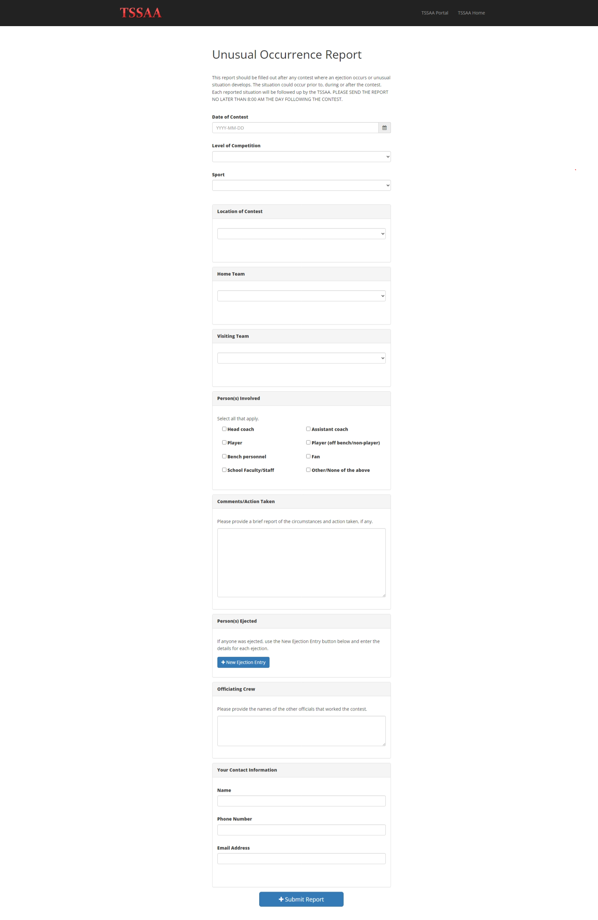

- Paste your detailed report in the comments section and fill out the report. Remember that if only gives us 3 options in the reason tab: “unsporting behavior,” “fighting” “flagrant foul.” Just choose the best option as all of these are not soccer terms.
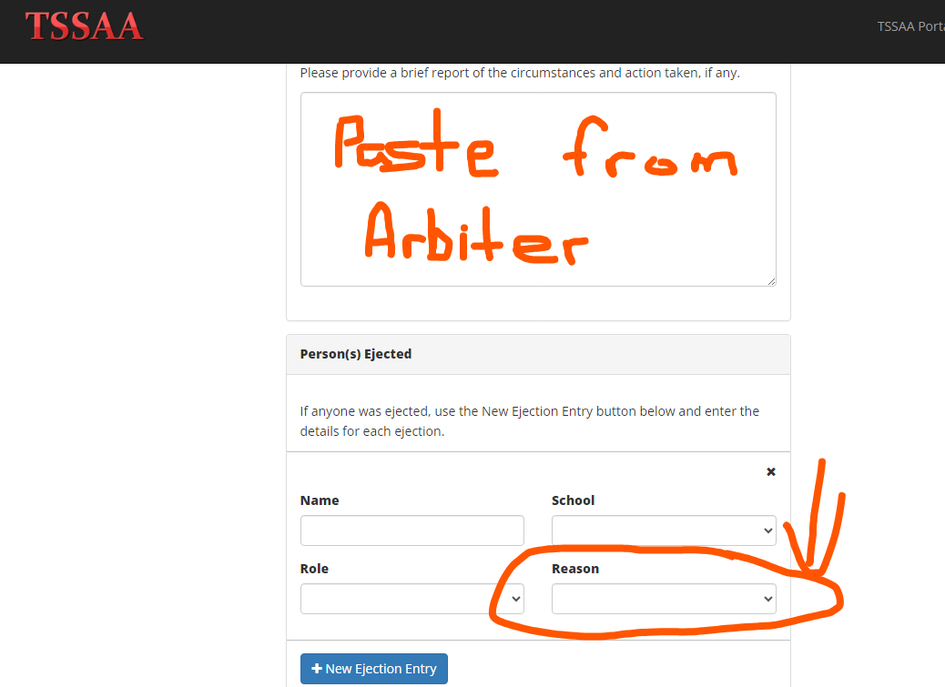

Examples of a disqualification report:
***below are comments that were heard in previous games and TSSAA has requested when filing a report to be precise on the language that was being said. Do not censor and only state facts
- #7 Jess Erikson, for Team MTSOA, shown a red card and disqualified from the game for committing a serious foul play. #7 performed a tackle with excessive force, hitting the player from behind and in the calf area. He left without further incidence
- #8 Tim Stewart, for Team MTSOA, disqualified in the 48th minute for using foul and abusive language say, “that’s a fucking bullshit call.” He remained in the team area without further incidence.
- The game administrator was asked to stand near the MTSOA section due to foul and abusive language being heard but unable to identify and isolate a specific spectator. The game administrator did so with no further incidence noted
- The game administrator was asked to remove two spectators in the 37th minute for using foul and abusive language saying “that’s a fucking bullshit call.” The game administrator did so and the spectators were identified for team MTSOA.
- The game administrator was asked to remove a spectator in the 26th minute for making racial remarks toward team A stating, “they wouldn’t have a team if you checked their green card, they would all be deported.” The spectator was identified to be with team MTSOA. In the 52nd minute the game administrator was asked to remove a spectator that was wearing team MTSOA apparel, for using foul and abusive language stating “fucking hit them again.”

