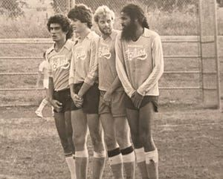
Nashville Blues players Eugenia Singer (far left), Larry Tilley (middle left), Nick Grimes (middle right), and Devinder Sandhu (far right) form a defensive wall, anticipating an incoming free kick in a game against the Fort Campbell Club at the Howard School in Nashville, Spring 1979
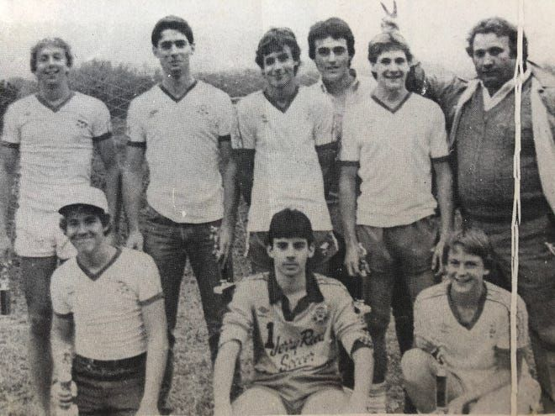
Jose Fernandez (top, right) poses with goalkeeper Otey Smithson (center) for team photo with his Under-16 Jerry Reed Express team in 1982

